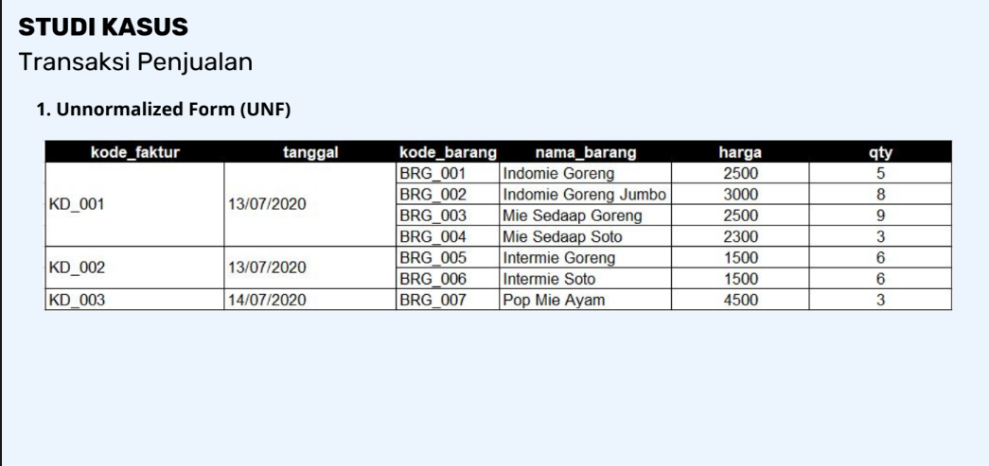

1. First Normal Form (1NF)

|  |  |  |  |  |  |
| --- | --- | --- | --- | --- | --- |
| **Kode_Faktur** | **Tanggal** | **Kode_Barang** | **Nama_Barang** | **Harga** | **Qty** |
| KD_001 | 13/07/2020 | BRG_001 | Indomie Goreng | 2500 | 5 |
| KD_001 | 13/07/2020 | BRG_002 | Indomie Goreng Jumbo | 3000 | 8 |
| KD_001 | 13/07/2020 | BRG_003 | Mie Sedaap Goreng | 2500 | 9 |
| KD_001 | 13/07/2020 | BRG_004 | Mie Sedap Soto | 2300 | 3 |
| KD_002 | 13/07/2020 | BRG_005 | Intermie Goreng | 1500 | 6 |
| KD_002 | 13/07/2020 | BRG_006 | Intermie Soto | 1500 | 6 |
| KD_003 | 14/07/2020 | BRG_007 | Pop Mie Ayam | 4500 | 3 |

1. Second Normal Form (2NF)

Tabel Faktur

|  |  |  |  |
| --- | --- | --- | --- |
| **Kode_Faktur** | **Tanggal** | **Kode_Barang** | **Qty** |
| KD_001 | 13/07/2020 | BRG_001 | 5 |
| KD_001 | 13/07/2020 | BRG_002 | 8 |
| KD_001 | 13/07/2020 | BRG_003 | 9 |
| KD_001 | 13/07/2020 | BRG_004 | 3 |
| KD_002 | 13/07/2020 | BRG_005 | 6 |
| KD_002 | 13/07/2020 | BRG_006 | 6 |
| KD_003 | 14/07/2020 | BRG_007 | 3 |

Tabel Barang

|  |  |  |
| --- | --- | --- |
| **Kode_Barang** | **Nama_Barang** | **Harga** |
| BRG_001 | Indomie Goreng | 2500 |
| BRG_002 | Indomie Goreng Jumbo | 3000 |
| BRG_003 | Mie Sedaap Goreng | 2500 |
| BRG_004 | Mie Sedap Soto | 2300 |
| BRG_005 | Intermie Goreng | 1500 |
| BRG_006 | Intermie Soto | 1500 |
| BRG_007 | Pop Mie Ayam | 4500 |

1. Third Normal Form (3NF)

Tabel Faktur

|  |  |
| --- | --- |
| **Kode_Faktur** | **Tanggal** |
| KD_001 | 13/07/2020 |
| KD_002 | 13/07/2020 |
| KD_003 | 14/07/2020 |

Tabel Barang

|  |  |  |
| --- | --- | --- |
| **Kode_Barang** | **Nama_Barang** | **Harga** |
| BRG_001 | Indomie Goreng | 2500 |
| BRG_002 | Indomie Goreng Jumbo | 3000 |
| BRG_003 | Mie Sedaap Goreng | 2500 |
| BRG_004 | Mie Sedap Soto | 2300 |
| BRG_005 | Intermie Goreng | 1500 |
| BRG_006 | Intermie Soto | 1500 |
| BRG_007 | Pop Mie Ayam | 4500 |

Tabel Detail Faktur Transaksi

|  |  |  |  |  |
| --- | --- | --- | --- | --- |
| **Kode_Faktur** | **Kode_Barang** | **Nama_Barang** | **Harga** | **Qty** |
| KD_001 | BRG_001 | Indomie Goreng | 2500 | 5 |
| KD_001 | BRG_002 | Indomie Goreng Jumbo | 3000 | 8 |
| KD_001 | BRG_003 | Mie Sedaap Goreng | 2500 | 9 |
| KD_001 | BRG_004 | Mie Sedap Soto | 2300 | 3 |
| KD_002 | BRG_005 | Intermie Goreng | 1500 | 6 |
| KD_002 | BRG_006 | Intermie Soto | 1500 | 6 |
| KD_003 | BRG_007 | Pop Mie Ayam | 4500 | 3 |

**DESIGN DATABASE**

*

1

1

*

**Tbl_barang**

Kode_barang Varchar(20)Primary Key;

Nama_barang Varchar(50);

Harga int;

**Tbl_faktur**

Kode_faktur Varchar(20)PrimaryKey;

Tanggal Date;

**Tbl_DetailTransaksi**

Kode_faktur Varchar(20)Foreign Key;

Kode_barang Varchar(20) Foreign Key;

Qty int;

